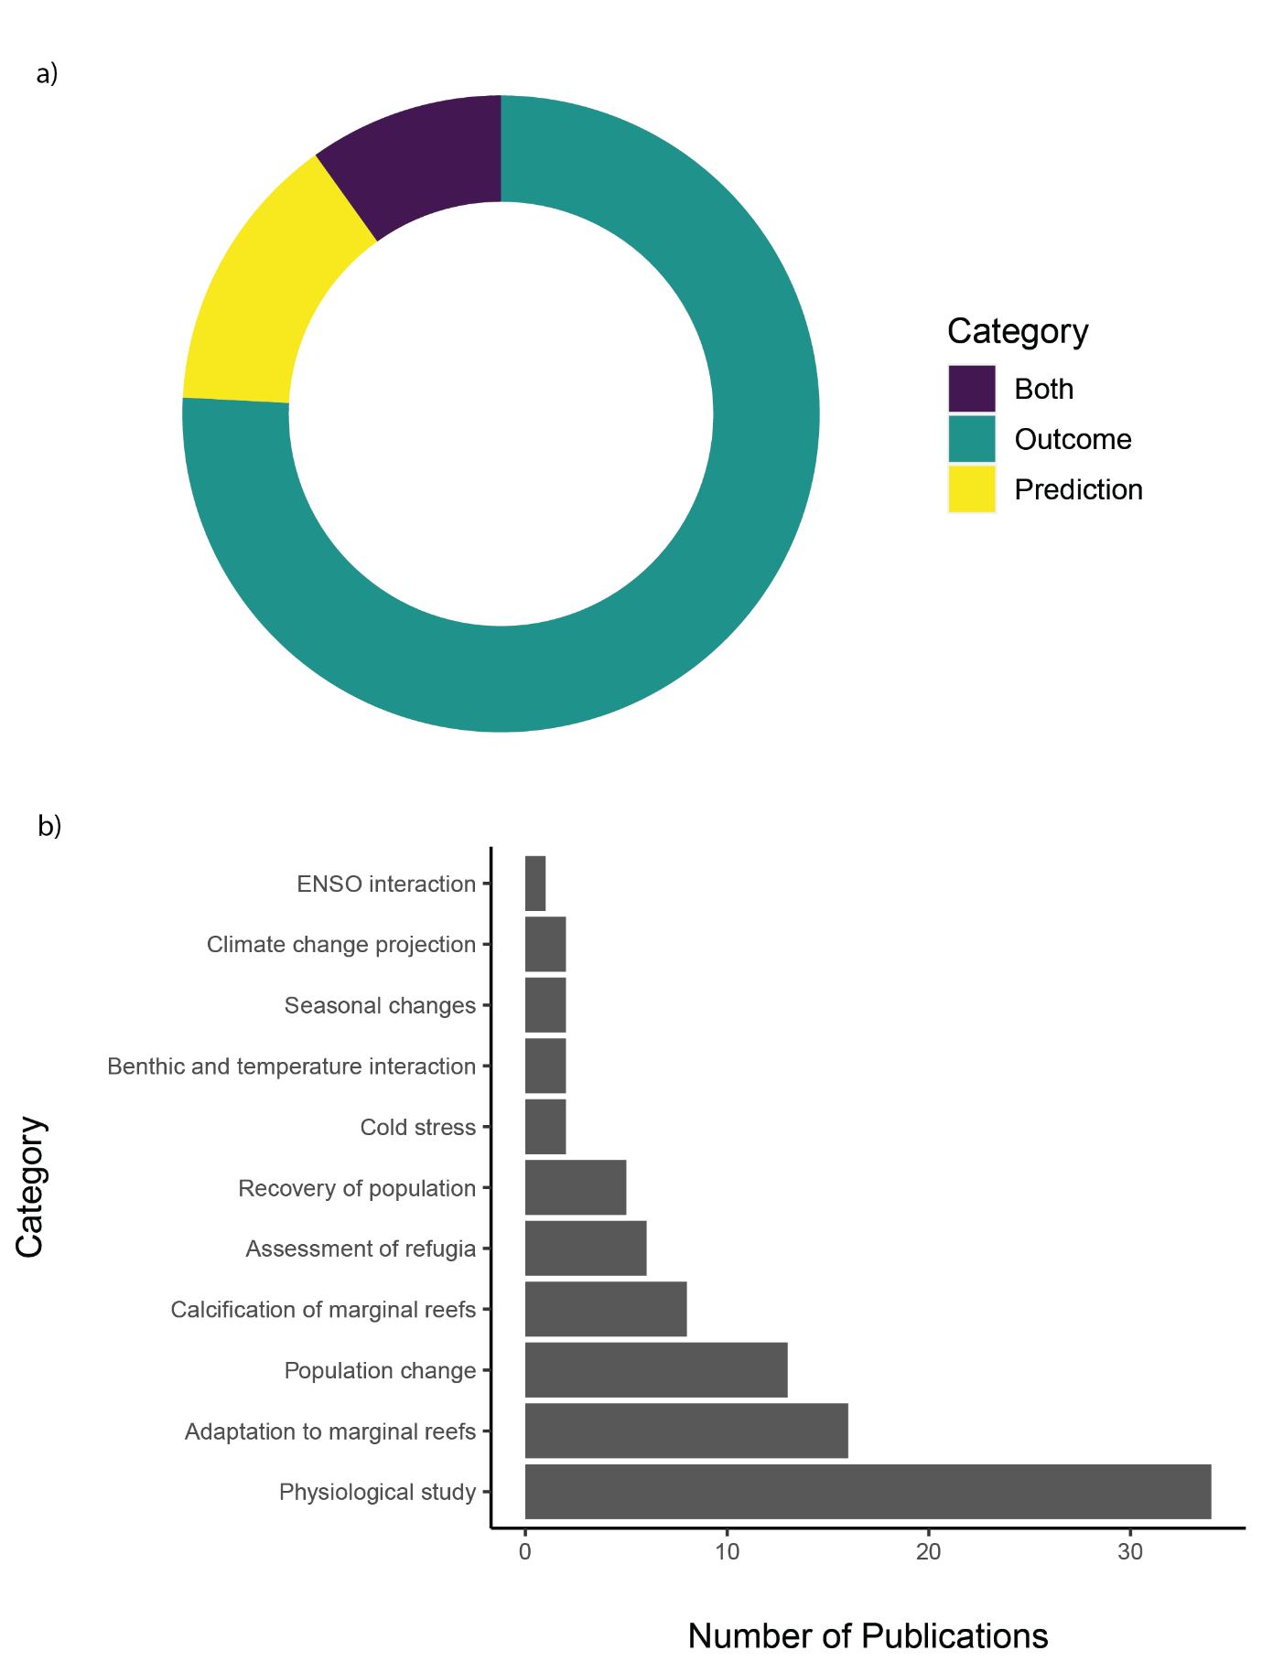

Figure 14 Proportion of literature included in this systematic map that include outcome and/or prediction. b) Categories of outcome/prediction and their number of publications respectively.